

***AIR QUALITY MONITORING -IOT***

Phase 5: Project Documentation and

Submission

SUBMITTED BY :

**MALINI . S _ 411521106030**

**AIR QUALITY MONITORING**

**Phase 5: Project Documentation and Submission**

# INTRODUCTION:

Air quality monitoring is the systematic process of measuring and assessing the composition of the air in a specific location to determine the presence of pollutants and their concentration. It plays a crucial role in environmental protection and public health. The primary objectives of air quality monitoring include:

1. Pollutant Detection: Identifying and quantifying various pollutants in the atmosphere, such as particulate matter (PM), gases like carbon monoxide (CO), sulfur dioxide (SO2), nitrogen oxides (NOx), ozone (O3), and volatile organic compounds (VOCs).
2. Regulatory Compliance: Ensuring that air quality meets government-set standards and regulations to safeguard human health and the environment.
3. Public Health: Monitoring air quality is essential to protect public health. Poor air quality can lead to respiratory problems, cardiovascular diseases, and other health issues.
4. Environmental Protection: It helps in assessing the impact of human activities, such as industrial emissions and vehicular traffic, on the environment, including air quality, ecosystems, and climate change.

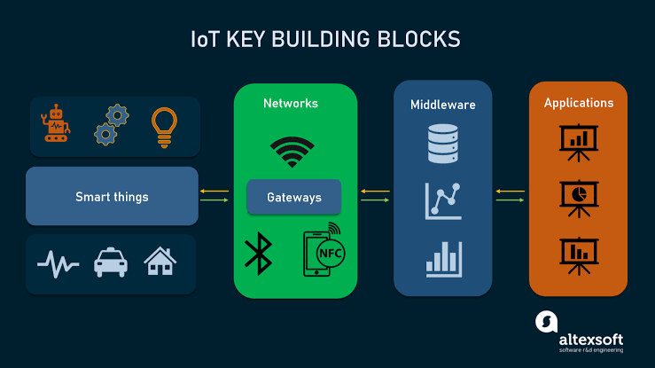

Air quality monitoring involves the use of various instruments and technologies, including air quality sensors, meteorological instruments, and data analysis systems. Data collected from monitoring stations is analyzed and used to make informed decisions on pollution control, policy development, and public advisories. Continuous monitoring and real-time data reporting are increasingly important in addressing air quality issues.

# PROJECT OBJECTIVES:

The specific objectives of an air quality monitoring project can vary depending on its scope and purpose, but some common project objectives include:

1. Pollutant Assessment: To measure and analyze the concentration of specific air pollutants (e.g., PM2.5, PM10, CO, NO2, SO2, O3, VOCs) in a particular area or region.
2. Compliance Monitoring: To ensure that air quality in the project area meets or adheres to local, national, or international air quality standards and regulations.
3. Public Health Protection: To assess and mitigate health risks associated with poor air quality by providing data for public advisories and interventions.
4. Emission Source Identification: To identify and quantify the sources of pollution, such as industrial facilities, transportation, or natural sources, which may contribute to air pollution.
5. Environmental Impact Assessment: To understand the impact of air quality on ecosystems, including forests, bodies of water, and biodiversity, and to develop strategies for protection and conservation.
6. Trend Analysis: To track changes in air quality over time, including seasonal variations and long-term trends, and to support research on climate change.
7. Early Warning System: To provide real-time or near-real-time data for immediate response to air quality events, such as wildfires, industrial accidents, or natural disasters.
8. Community Engagement: To involve and educate the community in air quality monitoring efforts and raise awareness about the importance of clean air.
9. Policy and Regulatory Support: To provide data and insights that inform the development of air quality policies, regulations, and emission control strategies.
10. Data Transparency: To make air quality data accessible to the public, researchers, and policymakers, promoting transparency and accountability.
11. Research and Innovation: To support research in the field of air quality monitoring, leading to the development of new technologies and improved monitoring methods.

The specific objectives of an air quality monitoring project should be defined at the outset to ensure that the project's goals are clear, and the data collected is used effectively to address air quality issues and protect the environment and public health.

# IOT DEVICES:

IoT (Internet of Things) devices play a crucial role

in modern air quality monitoring by providing real-time data collection, transmission, and analysis. The specific IoT devices required for an air quality monitoring project may vary, but some common components include:

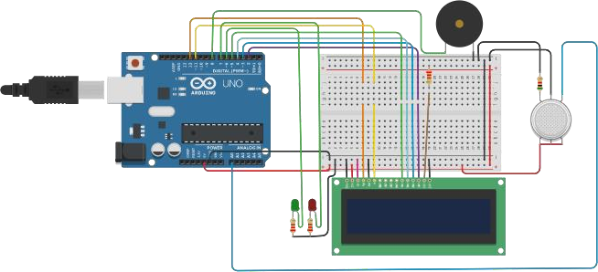

1. Air Quality Sensors: These sensors measure various air pollutants such as particulate matter (PM), gases like carbon monoxide (CO), nitrogen dioxide (NO2), sulfur dioxide (SO2), ozone (O3), and volatile organic compounds (VOCs).
2. Meteorological Sensors: These sensors collect data on temperature, humidity, wind speed, wind direction, and

atmospheric pressure, which are essential for understanding how weather conditions affect air quality.

1. Data Logger/Processor: A device or system that collects, stores, and processes the data from the sensors. It may include microcontrollers or dedicated data loggers.
2. Communication Modules: IoT devices need communication capabilities to transmit data to a central server or database. This can be achieved through Wi-Fi, cellular networks, LoRa, or other wireless communication protocols.
3. Power Supply: Depending on the location of the monitoring station, IoT devices may be powered by batteries, solar panels, or an external power source.
4. GPS Module: To provide location data, which is crucial for mapping air quality data to specific geographical areas.
5. Enclosure/Protection: To shield the IoT devices from environmental factors like rain, dust, and extreme temperatures.
6. Remote Control and Monitoring: In some cases, IoT devices may include remote control features to adjust monitoring parameters and monitor device status remotely.
7. Data Transmission and Visualization Software: This software is used to collect, store, analyze, and visualize the data collected by IoT devices. It's typically cloud-based and allows real-time access to air quality information.
8. User Interface: A user-friendly interface, often accessible via a web application or mobile app, for users to access air quality data and receive alerts or notifications.

The choice of IoT devices and sensors can depend on factors such as the project's budget, the specific pollutants of concern, the intended location, and the required level of accuracy. In addition, it's important to consider calibration and maintenance requirements to ensure the reliability of the monitoring system.

Keep in mind that technology in this field is continually evolving, and new devices and sensors may become available, offering enhanced capabilities for air quality monitoring.

# DEVICE SETUP:

Setting up an air quality monitoring device involves several steps. Below is a general overview of the device setup process:

1. Select the Monitoring Location:
   * Choose the location for the monitoring device. It should be representative of the area you want to monitor, considering factors like pollution sources and public exposure.
2. Install the Device:
   * Mount the device in a suitable location, ensuring it is secure and protected from environmental factors (e.g., rain, extreme temperatures). Ensure the device has good exposure to the surrounding air for accurate measurements.
3. Connect Sensors:
   * Connect the air quality sensors and any additional sensors, such as meteorological sensors, to the monitoring device. Follow the manufacturer's instructions for sensor installation and calibration.
4. Power Supply:
   * Provide power to the monitoring device. This can be through batteries, a solar panel, or a connection to a local power source, depending on your setup and location.
5. Network Connectivity:
   * Set up the device's communication module to connect to the internet. Configure Wi-Fi, cellular data, or other communication protocols as needed.
6. Data Logger/Processor:
   * Configure the data logger or processor to collect data from the sensors at regular intervals. Set up data storage and ensure proper timestamping.
7. GPS Module (if applicable):
   * If your device includes a GPS module, configure it to provide location data.
8. Calibration:
   * Calibrate the sensors to ensure accuracy. Follow the manufacturer's guidelines for calibration procedures and schedule regular maintenance.
9. Data Transmission:
   * Set up data transmission to a central server or cloud-based platform. Ensure the data is securely transmitted and stored.
10. Data Visualization:
    * Use data visualization software to access and analyze the data collected by the monitoring device. Set up dashboards and alerts as needed.
11. User Interface:
    * If applicable, create a user interface for accessing air quality data and receiving notifications. Ensure it is user-friendly and provides relevant information.
12. Data Quality Control:
    * Implement data quality control measures to identify and address issues with the data, such as outliers or sensor malfunctions.
13. Testing and Validation:
    * Conduct thorough testing and validation to ensure that the device is functioning correctly and providing accurate data.
14. Maintenance Plan:
    * Develop a maintenance plan that includes regular sensor calibration, device maintenance, and troubleshooting procedures.
15. Data Sharing:
    * Determine how and with whom you will share the air quality data, whether it's for public awareness, regulatory compliance, or research purposes.

Remember that the setup process may vary depending on the specific IoT devices and sensors you are using. Always refer to the manufacturer's documentation and guidelines for the devices you have to ensure proper installation and operation. Additionally, regularly monitor and maintain the device to ensure ongoing accuracy and reliability.

# PLATFORM DEVELOPMENT:

Developing a platform for air quality monitoring involves creating the software and infrastructure necessary to collect, store, analyze, and present air quality data to users. Here are the key steps in platform development:

1. Define Requirements:
   * Clearly define the objectives and requirements of the platform, including the types of data to be collected, the user interface, and any specific features like data visualization or alerts.
2. Select Technology Stack:
   * Choose the technology stack for development, including programming languages, frameworks, and databases. The choice

depends on your project's needs and your development team's expertise.

1. Data Collection and Integration:
   * Set up data connectors to collect data from monitoring devices. Ensure data is gathered efficiently and accurately. This may involve integrating with IoT devices through APIs or communication protocols.
2. Data Storage:
   * Design a database structure to store air quality data securely.

Consider factors like data redundancy, scalability, and data retention policies.

1. Data Processing and Analysis:
   * Develop algorithms and processes for data processing and analysis. This could include real-time data validation, aggregation, and the calculation of air quality indices.

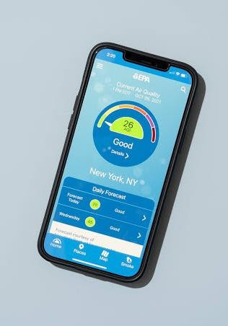

1. User Interface (UI) Development:
   * Create a user-friendly web application or mobile app for users to access air quality data. Design interactive dashboards for data visualization.
2. User Authentication and Access Control:
   * Implement user authentication and access control mechanisms to ensure that only authorized users can access certain data and features.
3. Alerts and Notifications:
   * Develop a system for generating and sending alerts and notifications to users when air quality reaches specific thresholds or when other events occur.
4. Mapping and Geographic Information System (GIS):
   * If location data is collected, incorporate mapping and GIS functionality to visualize air quality data on maps.
5. Scalability and Performance Optimization:
   * Ensure the platform is designed to scale to accommodate a growing amount of data and users. Optimize performance for fast data retrieval and response times.
6. Data Security:

- Implement robust security measures to protect data from unauthorized access and cyber threats. Encrypt sensitive information and regularly update security protocols.

1. Data Quality Control:
   * Develop tools and processes for data quality control, including outlier detection and error correction.
2. Reporting and Data Export:
   * Provide options for users to generate reports and export data for further analysis or regulatory compliance.
3. Integration with External Systems:
   * If needed, integrate the platform with external systems or services, such as government air quality monitoring networks or weather data sources.
4. Testing and Quality Assurance:
   * Thoroughly test the platform to identify and fix any issues or bugs. Conduct user testing to ensure the platform meets user expectations.
5. Documentation:
   * Create comprehensive documentation for users, administrators, and developers to understand how to use, maintain, and troubleshoot the platform.
6. Deployment and Maintenance:
   * Deploy the platform to a production environment and establish a maintenance plan to ensure ongoing functionality, updates, and support.
7. User Training:
   * Train users and administrators on how to use the platform effectively and interpret the air quality data.
8. Monitoring and Analytics:
   * Set up tools for monitoring platform performance and user engagement. Use analytics to make data-driven improvements.
9. Compliance and Regulation:

- Ensure the platform complies with any relevant data protection and regulatory requirements.

Platform development for air quality monitoring is a complex process that requires coordination between software developers, data scientists, domain experts, and potentially hardware specialists for IoT integration. It should be a well-planned project with a clear understanding of the end-users' needs and expectations.

CODE IMPLEMENTATION:

#include "MQ135.h" #include <SoftwareSerial.h> #define DEBUG true

SoftwareSerial esp8266(9,10); // This makes pin 9 of Arduino as RX pin and pin 10 of Arduino as the TX pin

const int sensorPin= 0; int air_quality;

#include <LiquidCrystal.h> LiquidCrystal lcd(12,11, 5, 4, 3, 2); void setup() {

pinMode(8, OUTPUT); lcd.begin(16,2); lcd.setCursor (0,0); lcd.print ("circuitdigest "); lcd.setCursor (0,1);

lcd.print ("Sensor Warming ");

delay(1000);

Serial.begin(115200);

esp8266.begin(115200); // your esp's baud rate might be different

sendData("AT+RST\r\n",2000,DEBUG); // reset module

sendData("AT+CWMODE=2\r\n",1000,DEBUG); // configure as access point

sendData("AT+CIFSR\r\n",1000,DEBUG); // get ip address

sendData("AT+CIPMUair_quality=1\r\n",1000,DEBUG); // configure for multiple connections

sendData("AT+CIPSERVER=1,80\r\n",1000,DEBUG); // turn on server on port 80

pinMode(sensorPin, INPUT); //Gas sensor will be an input to the arduino

lcd.clear();

}

void loop() {

MQ135 gasSensor = MQ135(A0);

float air_quality = gasSensor.getPPM();

if(esp8266.available()) // check if the esp is sending a message

{

if(esp8266.find("+IPD,"))

{

delay(1000);

int connectionId = esp8266.read()-48; /* We are subtracting 48 from the output because the read() function returns the ASCII decimal value and the first decimal number which is 0 starts at 48*/

String webpage = "<h1>IOT Air Pollution Monitoring System</h1>";

webpage += "<p><h2>"; webpage+= " Air Quality is "; webpage+= air_quality; webpage+=" PPM";

webpage += "<p>"; if (air_quality<=1000)

{

webpage+= "Fresh Air";

}

else if(air_quality<=2000 && air_quality>=1000)

{

webpage+= "Poor Air";

}

else if (air_quality>=2000 )

{

webpage+= "Danger! Move to Fresh Air";

}

webpage += "</h2></p></body>";

String cipSend = "AT+CIPSEND="; cipSend += connectionId; cipSend += ",";

cipSend +=webpage.length(); cipSend +="\r\n";

sendData(cipSend,1000,DEBUG); sendData(webpage,1000,DEBUG);

cipSend = "AT+CIPSEND=";

cipSend += connectionId; cipSend += ",";

cipSend +=webpage.length();

cipSend +="\r\n";

String closeCommand = "AT+CIPCLOSE=";

closeCommand+=connectionId; // append connection id closeCommand+="\r\n";

sendData(closeCommand,3000,DEBUG);

}

}

lcd.setCursor (0, 0); lcd.print ("Air Quality is "); lcd.print (air_quality); lcd.print (" PPM "); lcd.setCursor (0,1);

if (air_quality<=1000)

{

lcd.print("Fresh Air"); digitalWrite(8, LOW);

}

else if( air_quality>=1000 && air_quality<=2000 )

{

lcd.print("Poor Air, Open Windows"); digitalWrite(8, HIGH );

}

else if (air_quality>=2000 )

{

lcd.print("Danger! Move to Fresh Air"); digitalWrite(8, HIGH); // turn the LED on

}

lcd.scrollDisplayLeft(); delay(1000);

}

String sendData(String command, const int timeout, boolean debug)

{

String response = "";

esp8266.print(command); // send the read character to the esp8266

long int time = millis();

while( (time+timeout) > millis())

{

while(esp8266.available())

{

// The esp has data so display its output to the serial window char c = esp8266.read(); // read the next character.

response+=c;

}

}

if(debug)

{

Serial.print(response);

}

return response;

}

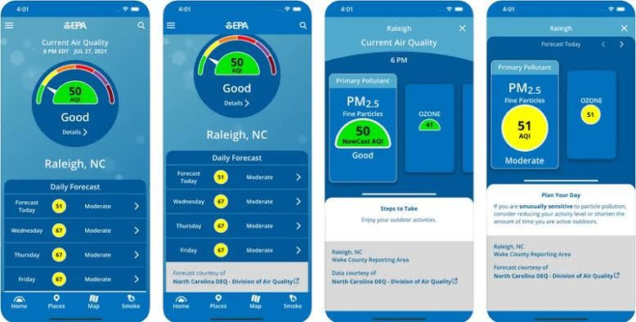

PROJECT DETAILS:

Designing an air quality monitoring project in detail involves careful planning, execution, and ongoing management. Below is a comprehensive outline of the steps to create an air quality monitoring project, from inception to operation:

1. Project Planning and Definition:
   * Project Objectives: Clearly define the objectives, including the pollutants to monitor, the project's scope (e.g., a city or specific industrial area), and the target audience (e.g., public, regulatory bodies).
   * Budget and Resources: Determine the project budget and allocate resources for equipment, technology, and personnel.
   * Project Timeline: Establish a project timeline with milestones and deadlines.
2. Site Selection:
   * Identify and select monitoring sites based on project objectives, ensuring representativeness of the area's air quality.
3. Equipment Procurement:
   * Select and purchase air quality monitoring devices, sensors, communication modules, and any required hardware.
4. Sensor Calibration and Installation:
   * Calibrate sensors to ensure data accuracy and consistency.
   * Install sensors at selected monitoring sites following best practices.
5. Data Communication and Management:
   * Develop a data management plan, including data storage, transmission, and backup.
   * Configure communication modules to transmit data to a central server or cloud platform.
6. Platform Development (if applicable):
   * If developing a platform, follow the steps outlined in the previous response for platform development.
7. Quality Control and Validation:
   * Establish a data quality control process, which includes outlier detection and error correction.
   * Conduct validation tests to ensure the accuracy of the monitoring devices.
8. Regulatory Compliance:
   * Ensure the project complies with local, national, or international regulations and standards for air quality monitoring.
9. Data Visualization and Reporting:
   * Develop data visualization tools, including real-time dashboards and historical data reports.
   * Create user-friendly interfaces for accessing air quality data.
10. Alerting System:
    * Implement an alerting system that notifies stakeholders and the public when air quality exceeds predefined thresholds.
11. Data Analysis and Research:
    * Analyze collected data to identify trends, patterns, and sources of pollution.
    * Conduct research to address specific environmental and health questions.
12. Public Awareness and Outreach:
    * Launch an awareness campaign to inform the public about the project's objectives, data availability, and health implications of air quality.
13. Maintenance and Calibration:
    * Establish a routine maintenance schedule for sensors and monitoring equipment.
    * Regularly calibrate sensors to maintain data accuracy.
14. Data Sharing and Open Access:
    * Make air quality data publicly accessible to researchers, policymakers, and the community through open data platforms.

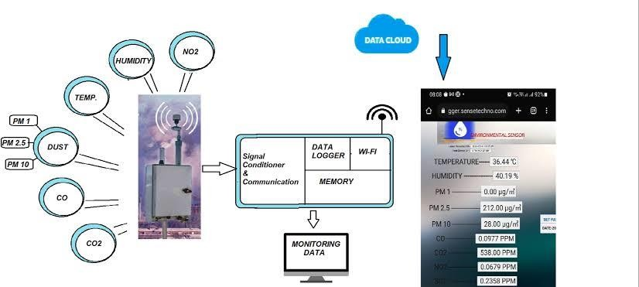

1. Monitoring and Evaluation:
   * Continuously monitor the project's performance and assess its impact on public health and environmental protection.
2. Scalability and Future Expansion:
   * Plan for the scalability and expansion of the project to cover more areas or include additional pollutants if necessary.
3. Emergency Response and Preparedness:
   * Develop a response plan for sudden air quality events, such as industrial accidents or wildfires.
4. Research and Innovation:
   * Stay updated with advancements in air quality monitoring technology and research to ensure the project remains state-of-the- art.
5. Compliance with Data Privacy and Security:
   * Ensure that collected data is handled securely and in compliance with data privacy regulations.
6. Budget and Funding Management:

- Keep track of project expenses and secure funding for ongoing operations and maintenance.

1. Collaborations and Partnerships:
   * Collaborate with governmental agencies, research institutions, and environmental organizations to enhance the project's reach and impact.

A well-detailed air quality monitoring project plan considers various aspects, including technology, data management, outreach, and compliance. It should be adaptable to changing conditions and designed to address current and future air quality challenges.

CONCLUSION:

In conclusion, air quality monitoring is a critical

endeavor with far-reaching implications for public health, environmental protection, and regulatory compliance. This comprehensive process involves the systematic measurement and analysis of air pollutants to ensure the well-being of communities and ecosystems. From the selection of monitoring sites to the development of sophisticated data platforms, each step is integral to the success of the project.

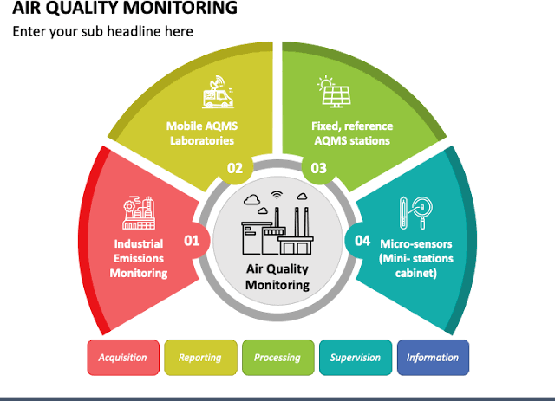

Collaboration with regulatory bodies, research institutions, and the wider community is key to addressing air quality challenges comprehensively and effectively